BSCS FINAL PROJECT
<Design and Test Specification>

THE SHIPPING SAINTS



Project Advisor

Presented by:

Faculty of Information Technology
University of Central Punjab
Design and Test Specification
SDP Phase III
THE SHIPPING SAINTS

Table of Contents
Table of Contents i
Revision History ii
1. Introduction 3
1.1 Product 3
1.2 Background 3
1.3 Objective(s)/Aim(s)/Target(s) 3
1.4 Scope 4
1.5 Business Goals 5
1.6 Document Conventions 5
1.7 Miscellaneous 5
2. Technical Architecture 6
2.1 Application and Data Architecture 6
2.2 Component Interactions and Collaborations 7
2.3 Design Reuse and Design Patterns 9
2.4 Technology Architecture 9
3. Detailed/Component Design 10
3.1 Component-Component Interface 10
3.2 Component-External Entities Interface 10
3.3 Component-Human Interface 11
4. Screenshots/Prototype 11
4.1 Screens 11
5. Other Design Details 23
6. Test Specification and Results 1
6.1 Test Case Specification 1
Sign-up 2
Merchant Selection of rider 2
Route selection 2
Driver accept the call 3
6.2 Summary of Test Results 3
7. Revised Project Plan 4
8. References 5
Appendix A: Glossary 5
Appendix B: IV & V Report 5

Revision History
Name | Date | Reason For Changes | Version

Introduction

Product
Now days there are many problems of deliveries in ecommerce industry.
- Late delivery is the biggest problem with current delivery system; our idea is for solving this problem.
- Delivery charges are high, current charges are about Rs.200, because of this the profit margins of ecommerce storeowner are reduced.
- Payment clearance of ecommerce storeowners from shipping companies are too late.
- The file of exported orders from the site will be upload on our application, so the user would not have to enter orders manually, which is a time consuming process.

Background
Our project targets the local ecommerce industry for the fast and affordable delivery cost for merchants. We will make an independent platform where a store owner deliver his/her orders they need to open the mobile app and put the order shipping details there according to the limit of one rider and then press the done and then the delivery riders who are register with our system received request notification for order, if he accepts the request he would have to pick-up order from the warehouse/store and update the status to parcel collected, then our app generate a shortest path using Artificial Intelligence from warehouse/store Destination and calculate the fare based on distance and parcel weight to all destinations, by this the cost is also reduced and when rider deliver a parcel he will update the status to order delivered and receive cash from customer, and if the customer doesn’t receive parcel the status will be updated to not received

Objective(s)/Aim(s)/Target(s)
Our app in made for your e-commerce platform. With a moto of fastest delivery within 24hours and may be less than an hour whose compatibility for Shopify and WordPress, as an E-Retailer you can rest assured that no matter what your E-Store platform is. Once you click on an order in your E-store dashboard, that order seamlessly falls into our shipping application where you can process it by performing
Generate Order and search for rider
Rider will pick up the items
Track the order
Bulk orders
Add or remove products from within the order
Leaves customer service or operation specific comments against the order
Shortest path selection
Order status and Payment received notification
You can also view your outstanding payments from and review your account statements and history

Scope
Basically it an app and web based application that delivers the products at your door step within one day in city. You can use our app for the below mentioned points
- For overnight delivery of urgent shipments across the country
- Safe and reliable delivery of valuable parcels across the nation within 48 hours
- Send heavy shipments at low prices by road nationwide
- Take advantage of quick, reliable deliveries within days to any corner in the country
- Reliable and speedy delivery of cargo to anywhere in country
- We go that extra mile when it comes to delivering your shipments.
  - Special handling & fragile shipments
  - Time definite shipments
  - Holiday & weekend deliveries
  - Individually customized solutions with us can package, protect and transport your valuables wherever you want.
Offering hassle-free payments, through our convenient collection solutions. The rider will submit the collected cash to the company’s Bank Account, then company will transfer the payment to merchant.
We can provide complete delivery solution for all your ecommerce needs with an matchless service. Being extremely customer focused, we are highly adaptable when it comes to our customer’s requirements. We can offer time-sensitive deliveries within a day, and deliveries outside normal business hours, we can deliver your shipment specifically where you want it, when you want it.

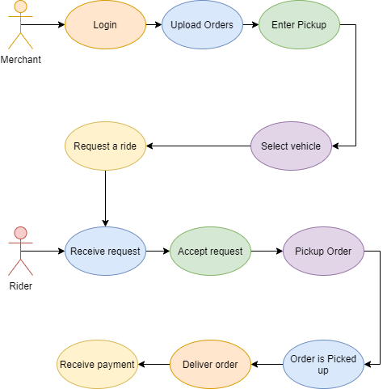

Business Goals
As we, all know about the e-commerce, industry is growing very rapidly. So every startup or business modal which is related to e commerce is must be beneficial. Because from last 2 – 3 years this industry is setting up new trends and enabling entrepreneur to make millions of dollars so if we can overcome the major issue which is delivery on time so our idea must be successful and if it will become successful then it must have a great business potential of making millions

Document Conventions
- Font for the description is Arial
- Arial size is 11.
- Heading font is Times, Size 18.
- Size for Sub-Heading Times, Size 14.
- Line Spacing between texts is 1.5.

Miscellaneous
As we know, some private entities are offering delivery, which is less, then an hour. However, these all are centralized companies but we also making our platform much efficient from which it will match the delivery time as we are not a ecommerce company itself but we will do this for our merchant by making our system as much efficient as we can.

Technical Architecture
- Is the system custom-built? COTS? | Yes this system is custom built
- What are the major application components? | We have two major component  RIDER:  The one who deliver the order  MERCHANT:  The one who place the order  AI algorithm for selecting path
- What data does the current system collect and manage? | It collects the information of riders and merchant  On basis of riders location it will tell where the rider is currently located  It tells the administration where we need more riders
- What is the basic application architecture (layered client/server, etc.)? | It is Client/Server architecture.
- What programming language is the current system built in? | Java or kotlin for app  Php, html, css, javascript for web
- What is the hardware platform that supports the current system? | Android
- What database platform supports the current system? | Firebase db
- Does the system have an end-user interface? If so, what type of user interface? (e.g., browser based thick client). | It will have android application for riders and merchant
- What is the basic network architecture (e.g., available on LAN, WAN, Internet)? | Internet based network architecture
Where is the system hosted (e.g., Enterprise Data Center, Other CMS Data Center, External Data Center | External Data Center

Application and Data Architecture
ER DIAGRAM:

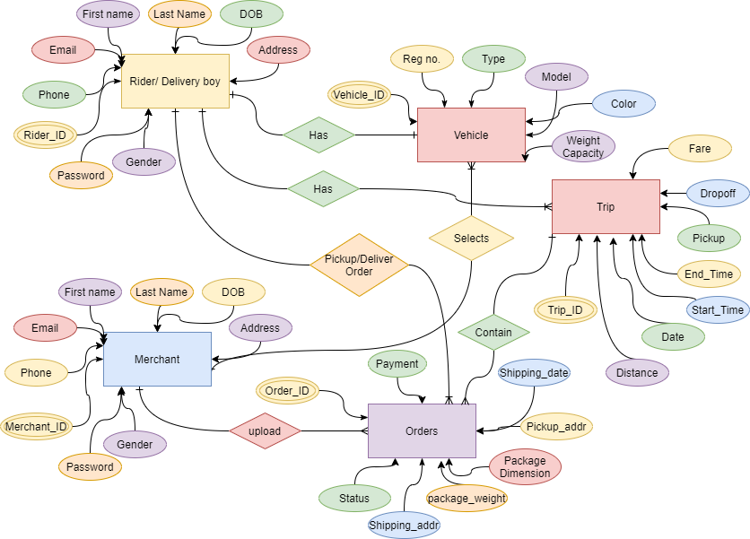

Component Interactions and Collaborations

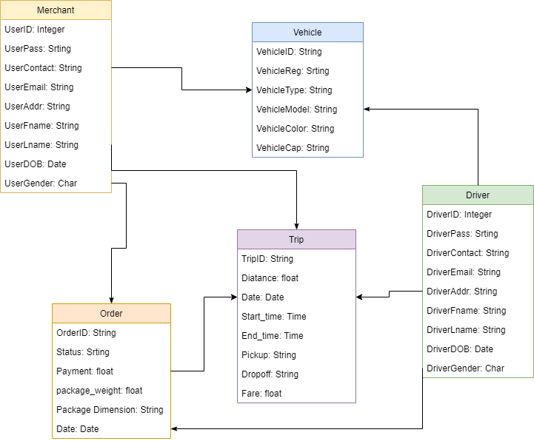
This system will have 2 users, merchant and riders, both users have to register on app to use . The registration process for merchant is simple, he can simply signup with email. But for rider, the registration process requires personal documentations for validation, and after some manual verification of documents by admin, the rider account will activated.

Design Reuse and Design Patterns
As we know our app is basically works like uber and careem in terms of vehicles selection , riders , payments, map integration and some other things so we can reuse the design of uber or careem in our system for getting our work fast and efficiently .

Technology Architecture
We are using different technology for our system and different algorithms from where our system would be more efficient and more productive. So all the entities, which we want to target, will use us happily so we are using firebase database, as this is one of the most secure database. Moreover, using kotlin or java as this is one of widely used language and does not affect our system performance. In addition, after this we are going to use travel sales man problem for finding best and shortest path for our rider from where the deliveries would be delivered as soon as possible. And we also put some filters like when there are rush hours, we also provides best routs where our riders delivers without facing rush and things like that and once the rider will called by the store merchant and store merchant have more number of orders. Then the vehicle nature then it will automatically shifted to the other respective vehicle and this shifting will be calculated based on area of.
DATABASE: FIREBASE
Framework: Android
APP FOR RIDER
APP FOR MERCHANT

Detailed/Component Design
As the registration process is describe in section 2.2, after the registration both merchant and rider have different interfaces because both users have different apps.
Our app will have these use cases interface:
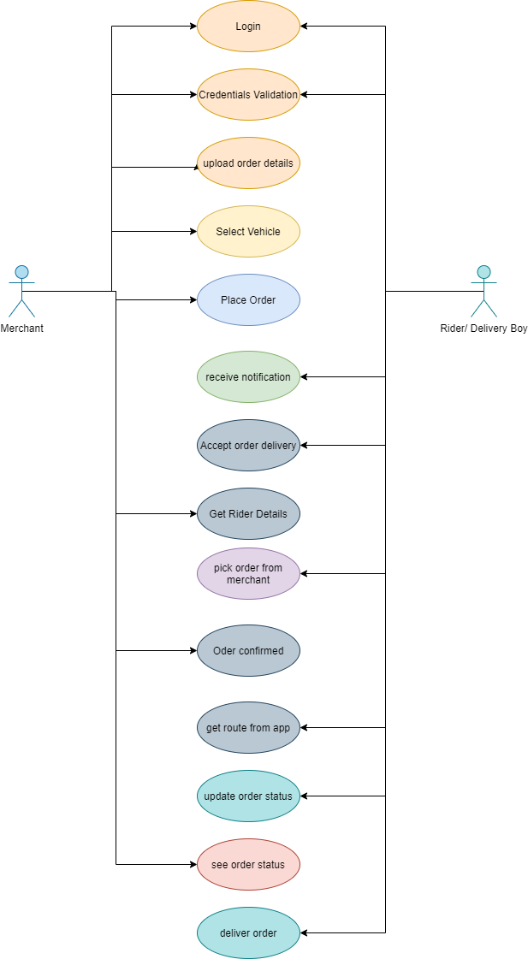

Component-Component Interface
Both Merchant and rider have different features to interact. Merchant have to login. Upload orders, select vehicle and place order. Then the request will sent to rider via notification. Rider can accept or reject order. If he accept the order, he have to pick up parcel from pickup point and deliver to given address.

Component-External Entities Interface

Our app needs integration of external payment gateway for payments. As we know, in Pakistan some banks provides payment gateways on strict verification of legal business documents. So we are figuring out that any bank provide sandbox environment to test payments.

Component-Human Interface

Screenshots/Prototype

Screens
MERCHANT SCREENS
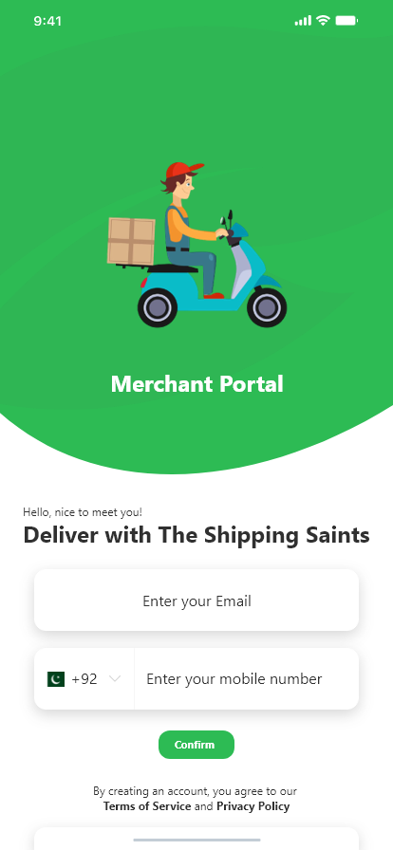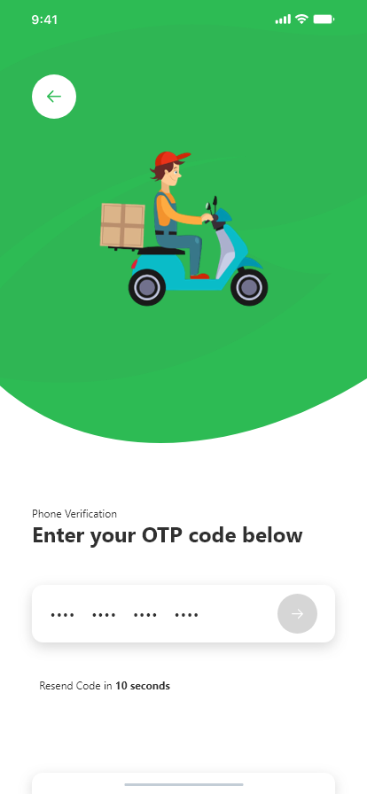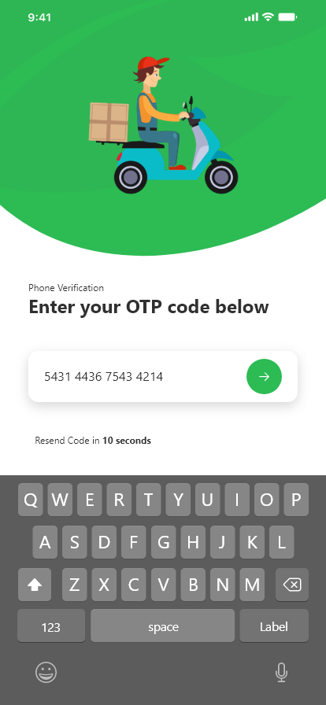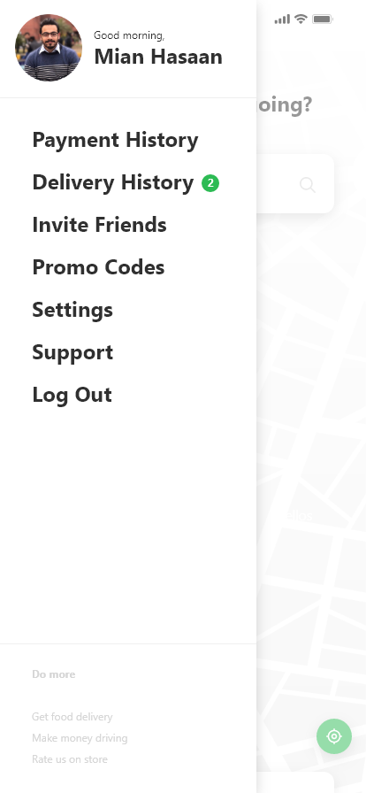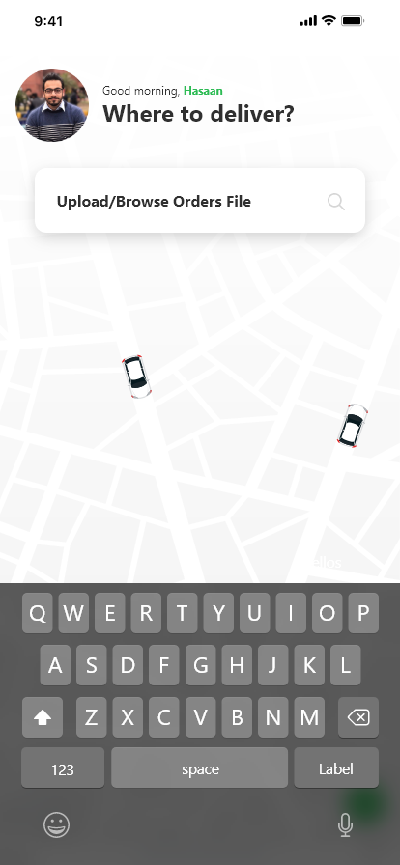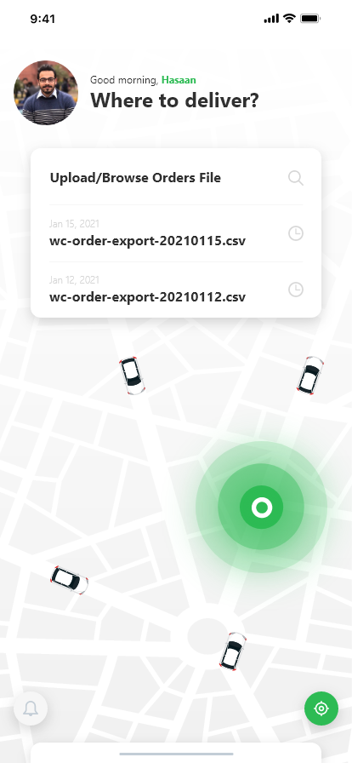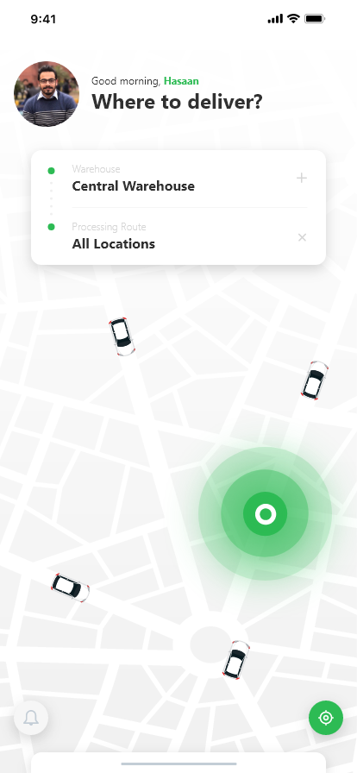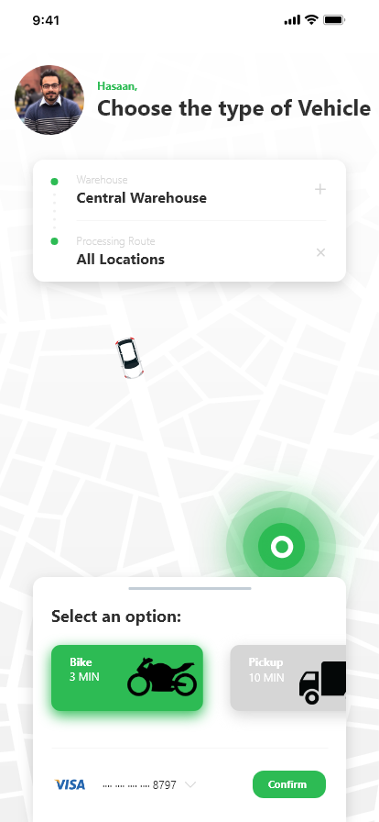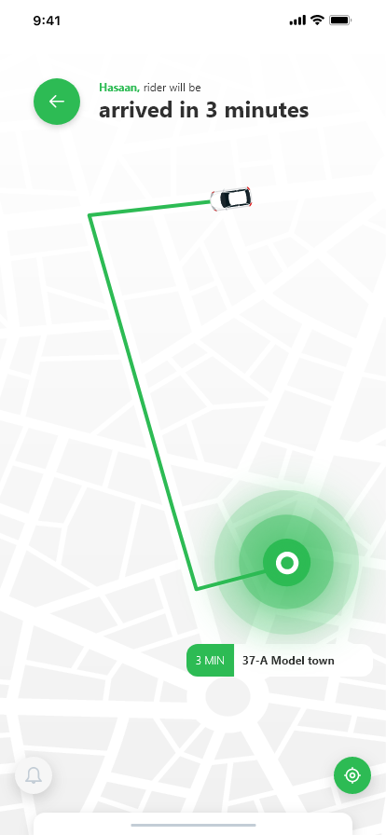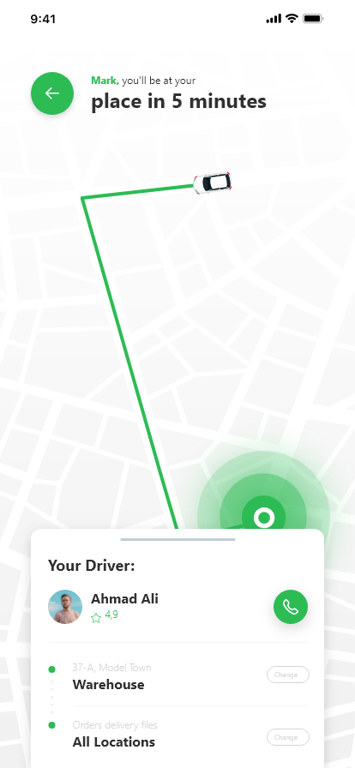
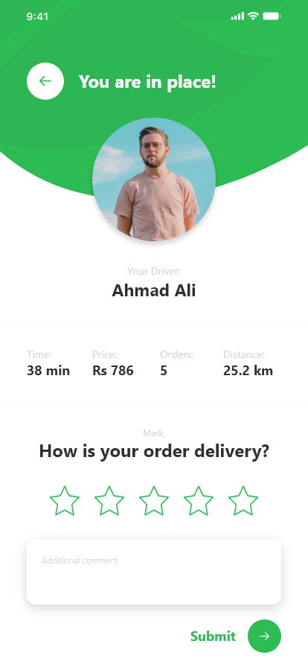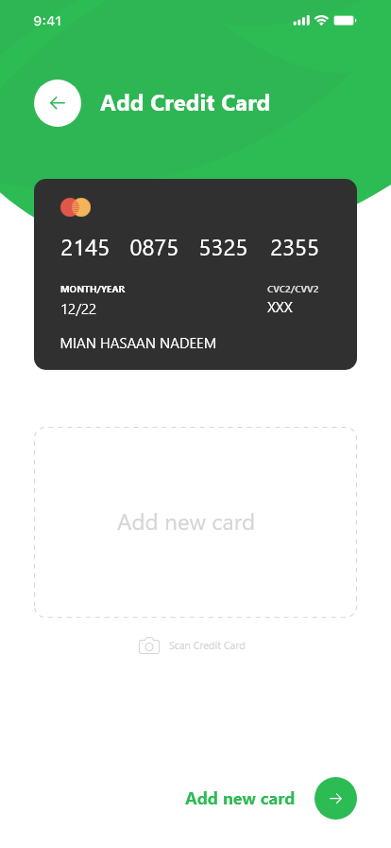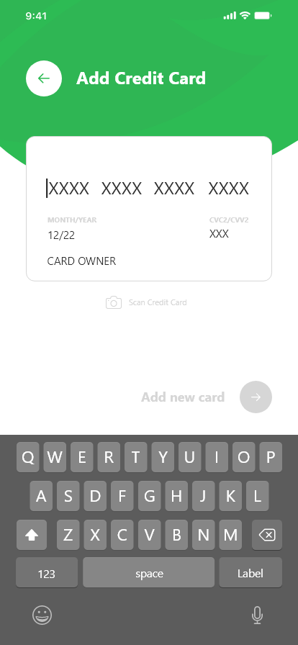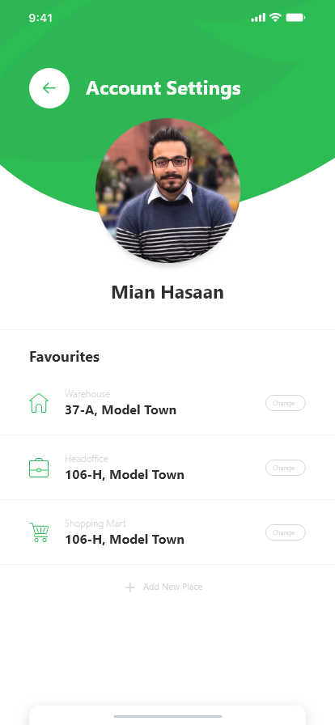
RIDER SCREENS
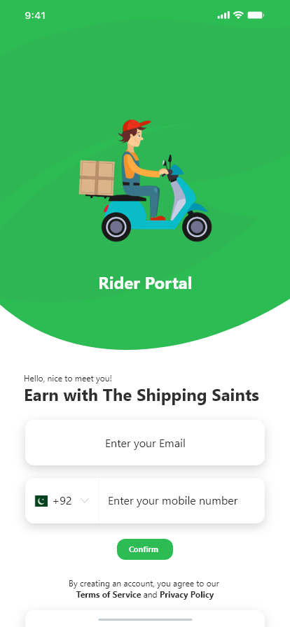
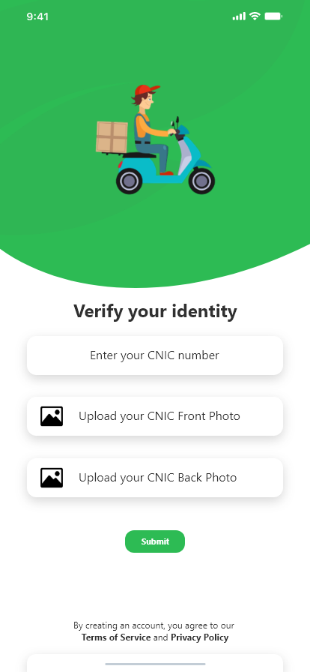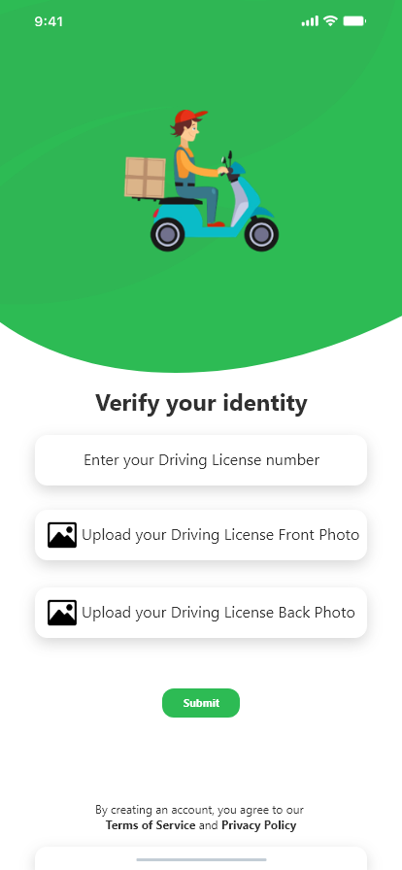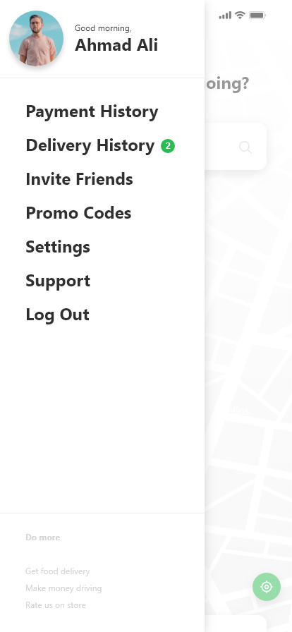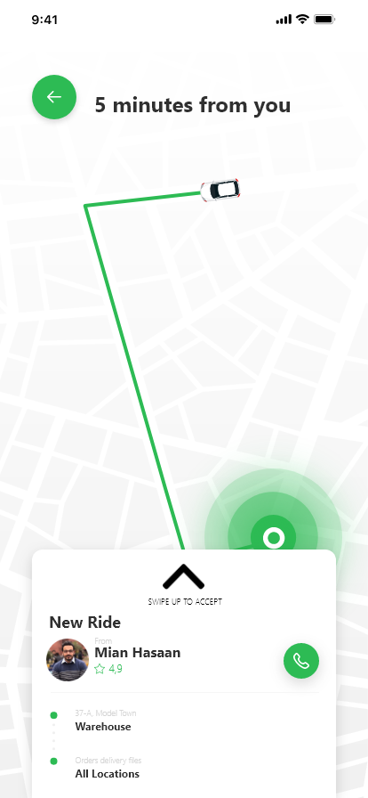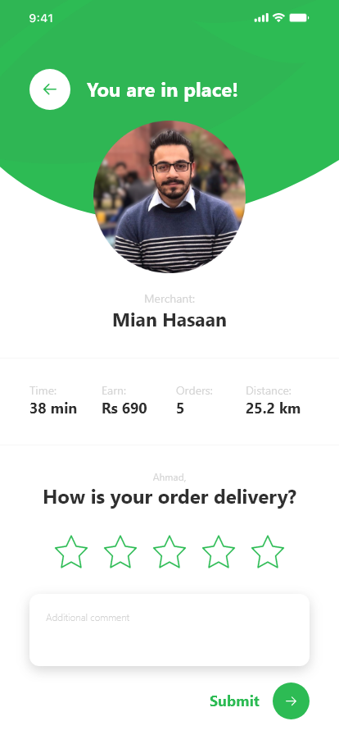

Other Design Details
Algorithm Analysis for shortest path:

Dijkstra’s Shortest Path Algorithm

The Dijkstra’s shortest path algorithm is the most commonly used to solve the single source shortest path problem today. For a graph G(V, E), where V is the set of vertices and E is the set of edges, the running time for finding a path between two vertices varies when different data structure are used. This project uses binary heap to implement Dijkstra’s algorithm although there are some data structures that may slightly improve the time complexity, such as Fibonacci heap that can purchase time complexity of O(V*log(V)) [6].

Dijkstra’s shortest path algorithm for each u G:
d[u] = infinity; parent[u] = NIL;
End for
d[s] = 0; // s is the start point H = {s}; // the heap
while NotEmpty(H) and targetNotFound: u = Extract_Min(H);
label u as examined;
for each v adjacent to u:
if d[v] > d[u] + w[u, v]:
d[v] = d[u] + w[u, v]; parent[v] = u; DecreaseKey[v, H];
Time Complexity:
The run time of first for loop is O(V). In each iteration of the while loop, Extract_Min of the heap is logV. The inner for loop iterates each adjacent node of the current node, the total run time is O(E). Therefore, the time complexity of this algorithm is O((V + E)*log(V) = O(E* log(V)). The correctness of this algorithm is well proved in [6].
As the number of nodes in a graph increases, the running time of the applied algorithm will become longer and longer. Usually, a road network of a city has more than 10^4 nodes. A fast shortest path algorithm becomes more desirable.

Basically, the structure of road networks is relative simple. They are large scaled, sparse and connected graph. When the Dijkstra algorithm is used to find the shortest path, it starts search from the start point and spreads as a circle until the radius arrives the destination. Most searches at the area opposite the direction of destination are useless. M. Fu et al. [4] described an optimal approach to find shortest path for Vehicle Navigation System by physically cutting off area within which the shortest path is not supposed to appear.

T2


Rec1 D

T1

S Rec2

Search Area of Dijkstra and Restricted Search Algorithm (S: Start point, D: Destination)

Instead of search the entire circle, the Restricted Search Method only search with the small area of the remaining part of rectangle Rec2 cutting off by the two bold straight lines. The rectangle Rec1 has the straight line of S and D as a diagonal and Rec2 is a rectangle extended from Rec1 by a threshold T2. The two straight bold lines parallel the

straight line of SD with a distance of T1. T1 and T2 are two variables that need to be decided to ensure that the optimal path is included within the restricted area. They usually range from 500m to 1500 m.

This project uses the following algorithm to achieve this goal. Restricted Search Algorithm:
for each u G:
d[u] = infinity; parent[u] = NIL;
End for
d[s] = 0;
H = {s};
while NotEmpty(H) and targetNotFound: u = Extract_Nin(H);
label u as examined;
for each v adjacent to u:
if outOfRange(v), then continue; if d[v] > d[u] + w[u, v], then
d[v] = d[u] + w[u, v]; parent[v] = u; DecreaseKey[v, H];

Procedure outOfRange(Constraint Area A, Vertex v):
//A is a polygon given;
//v is a Vertex being checked;
Make a straight-line L from v to the right of v; Counter = 0;
For each edge e of A
if L intersects with e
increase Counter by one; if Counter is even
return true;
else
return false
Time Complexity:
Suppose the nodes in the road network are distributed evenly.
Let density be C,
V*: the number of vertices examined by using Dijkstra algorithm. V: the number of vertices examined by using this algorithm.
Soptimal: searched area by using this algorithm. Sdij: searched area by using Dijkstra algorithm. K1, K2: the factors of threshold.
Then, the ratio P can be used to describe the improvement of efficiency, P = V/V*
= C* Soptimal / C* Sdij
<= 2 * T1 (R + T2 * √2) / πR²
= 2 * K1*R(R + K2* R*√2) / πR²
=2 * K1(1 + √2 * K2) / π
Since K1 and K2 are small number, the great improvement can be achieved. For instance, if K2 = 0.4, P ≈ K1.

Correctness:
There are two problems exist in this approach.
- The fixed threshold may not get the solution properly. As the distance from start point to the destination increases, the shortest path more likely spreads wider from the straight line of SD.
- The city traffic lines have different categories with different driving speed. The high way may be beyond the restricted area but in the shortest path.
To achieve a better solution, this project uses relative thresholds instead of the fixed ones, called factor K1, K2 (threshold / length of SD). To simplify the problem, they have same value in the implementation. The threshold proportionally increases with the distance from start point to the destination in a selected factor. The second problem could be solved by using logical position instead of physical location for each node. For example, upon a node being examined, its logical position will be the accumulation from the logical location of its parent by the cost of the edge between them. The cost of an edge is logical distance that relative to physical distance and road category The
logical location of start point is the same as its physical location. All nodes being examined use their logical position to decide if they are within the restricted area. This ensures that the nodes on different roads can be treated equally in searching. However, due to the time constraint, this project will not implement it in the program.
This algorithm actually uses the Dijkstra within the restricted area. It is obvious that a shortest path in this area will be found if the path exists. However, this shortest path may not be the shortest one in the whole area. Thus, it is optimal path with restricted area.

A* Search

The A* algorithm integrates a heuristic into a search procedure. Instead of choosing the next node with the least cost (as measured from the start node), the choice of node is based on the cost from the start node plus an estimate of proximity to the destination (a heuristic estimate). F. Engineer [2] described this approach to solve the problem of optimal path finding.
This project uses Euclidean distance as estimated distance to the destination. In the searching, the cost of a node V could be calculated as:
f(V) = distance from S to V + estimate of the distance to D.
= d(V) + h(V,D)
= d(V) + sqrt( (x(V) – x(D))² + (y(V) – y(D))²)
where x(V), y(D) and x(V), y(D) are the coordinates for node V and the destination node D.

The A* Search algorithm: for each u G:
d[u] = infinity; parent[u] = NIL;
End for
d[s] = 0;
f(V) = 0;
H = {s};
while NotEmpty(H) and targetNotFound: u = Extract_Min(H);
label u as examined;
for each v adjacent to u:
if d[v] > d[u] + w[u, v] , then
d[v] = d[u] + w[u, v]; p[v] = u;
f(v) = d[v] + h(v, D); DecreaseKey[v, H];

Time Complexity:
This algorithm does not improve worst case time complexity, but it improves average time complexity. The shortest path search starts from start point and expands node that goes towards the destination. Therefore, the run time is much shorter than the Dijkstra’s algorithm.
Correctness:
The algorithm uses the same approach as Dijkstra’s except that it uses accumulated cost of edge plus the Euclidean distance from current node to the destination. This value is used to decide the position of a node in the min heap. The one with smallest value will be selected and removed from the heap. In the implementation, this value only affects the searching order. It doesn’t modify the edge weights and accumulated distance. The accumulated distance is updated as the same way as Dijkstra when a node relax.
Therefore, this algorithm is same as Dijkstra and it is correct.

Test Specification and Results

Test Case Specification
LOG-IN SCREEN
Table 6.1: TC-1
Identifier | TC-1
Related requirements(s) | User needs to login in merchant or driver app
Short description | Must have login credential like password and id
Pre-condition(s) | Must be registered
Input data | Login credentials
Detailed steps | First need to on mobile app then select login and type its credentials
Expected result(s) | Login sucessfull
Post-condition(s) | Home page appears
Actual result(s)
Test Case Result

Sign-up
Identifier | TC-2
Related requirements(s) | User needs to signup in merchant or driver app
Short description | Creating new account
Pre-condition(s)
Input data | Fill all the credentials that is required
Detailed steps | First need to on mobile app then fill all the credentials
Expected result(s) | signup sucessfull
Post-condition(s) | Home page appears
Actual result(s)
Test Case Result

Merchant Selection of rider

Identifier | TC-3
Related requirements(s) | User needs to login in merchant
Short description | Login to app
Pre-condition(s) | Must be registered
Input data | Select or add the csv file
Detailed steps | After successful submission of file merchant will select the driver option appearing according to its orders
Expected result(s) | Driver will accept the call
Post-condition(s) | Driver data will be shown with its location
Actual result(s)
Test Case Result

Route selection

Identifier | TC-4
Related requirements(s) | User needs to login in merchant
Short description | Login to app
Pre-condition(s) | Must be registered
Input data | Select or add the csv file
Detailed steps | After successful submission of file the shortest path algorithm himself adjust them
Expected result(s) | The new file will be shown
Post-condition(s) | Most nearest driver will receive the call
Actual result(s)
Test Case Result

Driver accept the call

Identifier | TC-5
Related requirements(s) | User needs to login in driver app
Short description | Login to app
Pre-condition(s) | Must be registered
Input data | On his location to accept the call
Detailed steps | The merchant sent a call to the driver the driver wil accept it
Expected result(s) | Driver accept the call
Post-condition(s) | Merchant data will be shown with its location
Actual result(s)
Test Case Result

Summary of Test Results
<Provide in tabular form the defects found in each of your software modules. For example see Table 6.2 below.>

Table 6.2: Summary of Test Results
Module Name | Test cases run | Number of defects found | Number of defects corrected so far | Number of defects still need to be corrected
Module 1 (for example Bill Calculation Module, Speech Processing Unit | TC1, TC2,…
Module 2 | …
Module 3 | …
… | …
 | …
 | …
 | …
Complete System | <Sum all of the above> | <Sum all of the above> | <Sum all of the above> | <Sum all of the above>
Table 6.2: Project Completion Status
Module Name | Status  (Complete, Partially Implemented, Not Implemented)
Module 1 (for example Bill Calculation Module, Speech Processing Unit
Module 2 | …
Module 3 | …
Complete System | …

Revised Project Plan
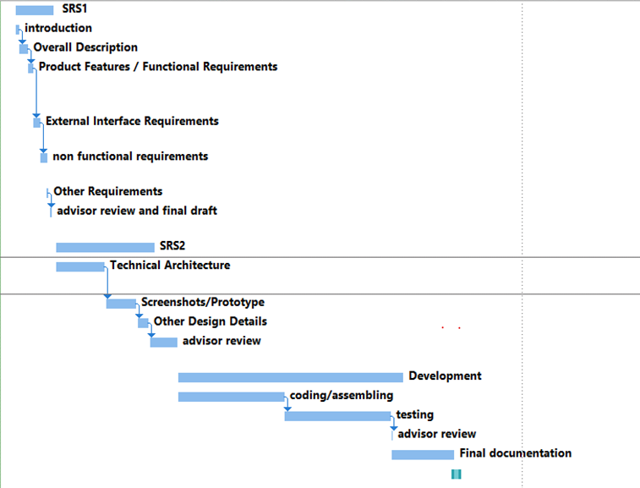

References
<List all books, conference papers, journal articles, websites, etc. used in preparing the content of this document. Provide enough information so that the reader could access a copy of each reference, including title, author, volume/edition number, page number(s), and publication year. Mention

Appendix A: Glossary
<Define all the terms necessary to properly interpret the SDS, including acronyms and abbreviations.>
Appendix B: IV & V Report
(Independent verification & validation)
IV & V Resource

Name Signature

S# | Defect Description | Origin Stage | Status | Fix Time
 |  |  |  | Hours | Minutes
1
2
3
…
Table 1: List of non-trivial defects

This document has been adapted from the following:
- Previous project templates at UCP
- High-level Technical Design, Centers for Medicare & Medicaid Services. (www.cms.gov)

